HOW TO MAKE SURE YOU HAVE SUFFICIENT ADMINISTRATOR ACCESS
To be able to run PLUS+1 Software tools you need to have administrator access, or in short;
- Access to install a program
- Access to the following places;
  - C:\Users\[Username]\AppData\Roaming – normally hidden in Windows so make Explorer show hidden files and folders (to show hidden files; Control Panel -> Folder Options -> “View” tab -> “Show hidden files, folders, and drivers)
  - C:\ProgramData
  - C:\Users\[Username]\Documents - this is the “My Documents” folder
  - C:\Program Files
- Use the same account for installing and running
Make sure you fulfil this by making the checks on the following pages.

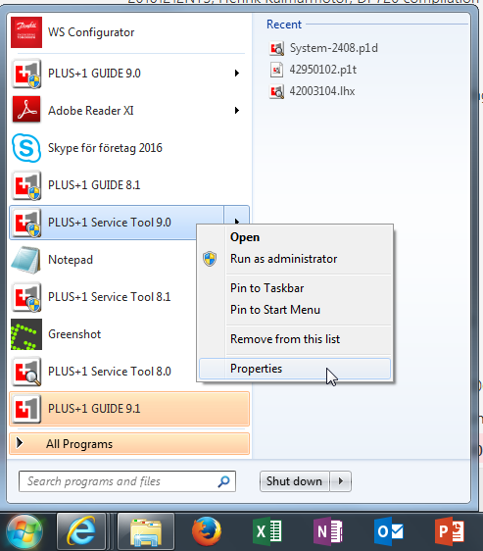
Run the program as an administrator
Start by going to your Windows Start menu and right click on your PLUS+1 GUIDE or Service Tool symbol. In the small box that opens you will find Properties at the bottom, click on that.

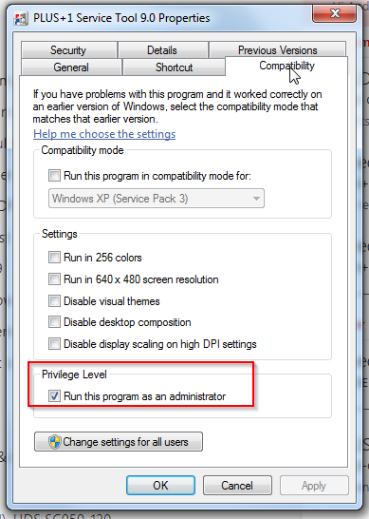
You will then have a dialog box open for PLUS+1 GUIDE/Service Tool x.x Properties. In this one, click on the tab Compatibility. At the bottom of this tab you have a heading, Privilege Level, and a check box for Run this program as administrator, check this one. You only need to do this change to the properties once for this version of the program. Now you will run the program as administrator every time you click on it in the Start menu or on any other shortcut. If you are not able to check this box, it is greyed out, this is the first indication that you don’t have sufficient administrator access on your computer/user account.

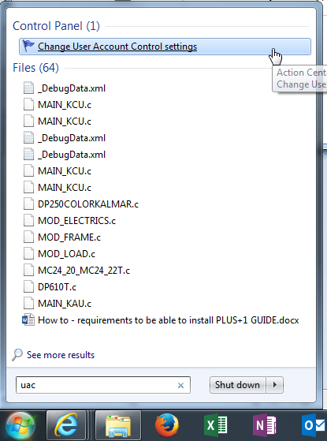
User Account Control settings
Another way to check that you have sufficient administrator access is to go to the Windows Start menu and in the search field at the bottom write uac. At the top the search result will come up with a link to Change User Account Control settings, click on this.

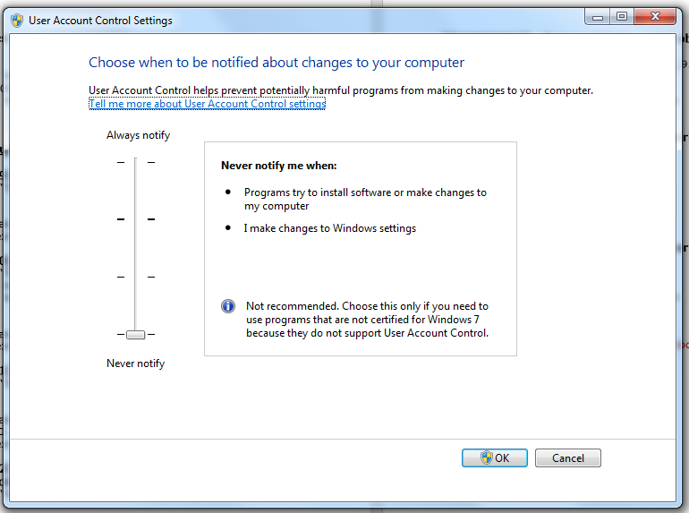
That gives you this dialog when you need to make sure you are able to move the bar to the bottom, that’s where it needs to be for PLUS+1 GUIDE and Service tool. If you are not able to move the bar, it is greyed out, this is the second indication that you don’t have sufficient administrator access on your computer/user account.

