How to use global variables in a C function in GUIDE
First a word of warning: it is not recommended to use global variables since they are a common source of errors in programs.

Step 1, create a c/h pair of files to hold the global variables:
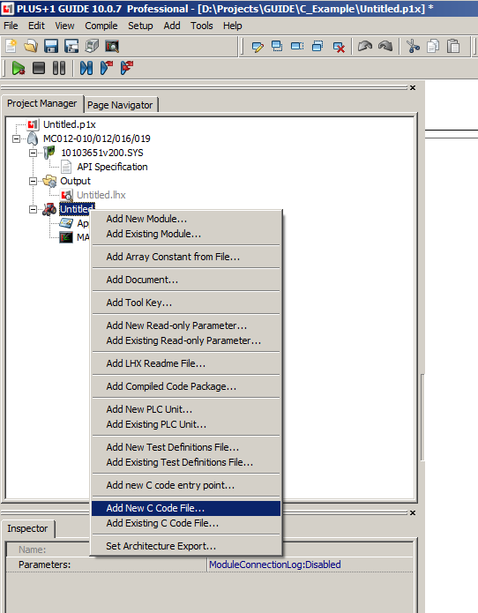
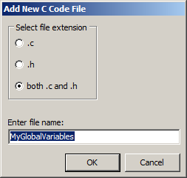

Step 2, add your global variables into the .c file, extern in the .h file:
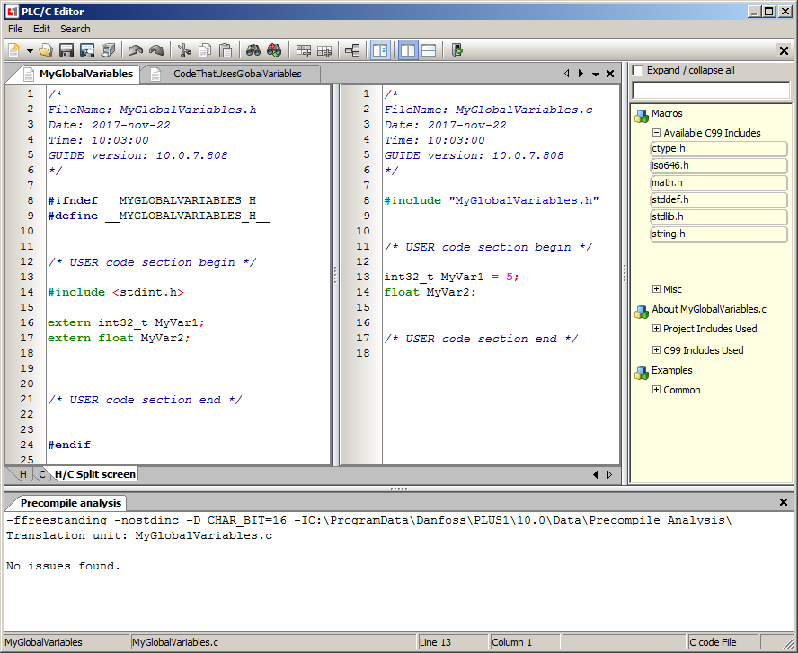

Step 3a, using global variables in a C function in a C file:
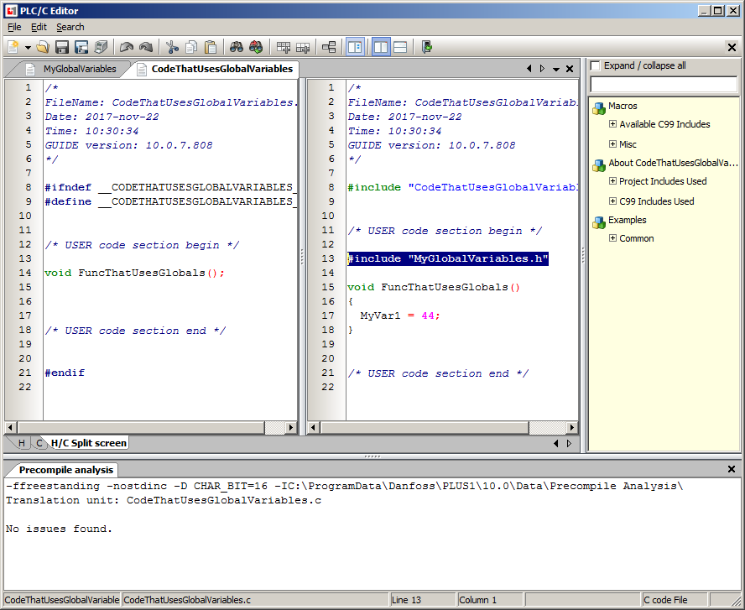
Make sure to include the file MyGlobalVariables.h.
Then you can use global variables such as MyVar1 in your C code function.

Step 3b, using global variables in a C language PLC POU:
If there is a C code POU named for example MyCpou:
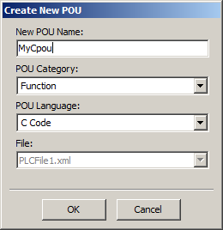

To use global C variables from this POU, first make the global variables header file available to PLC code:
